1. 新建Qt工程文件，创建设计师界面类文件dialog和dialog 2，创建Resources文件并把图片添加进去

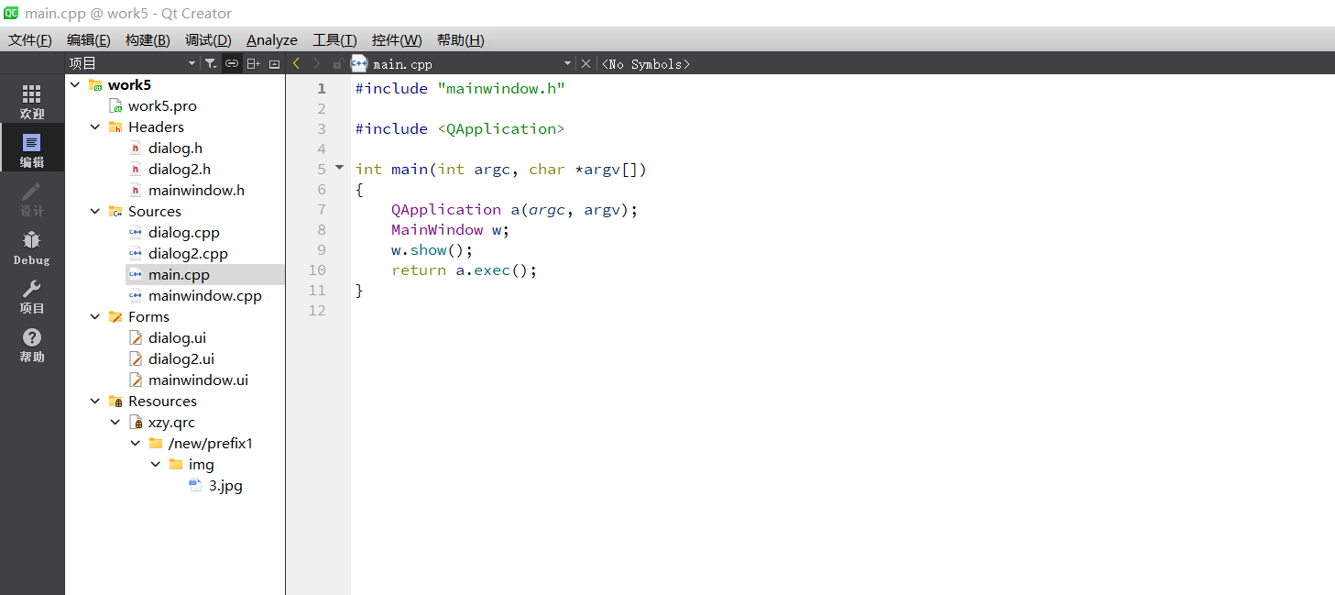

1. 设置窗口大小为400X300分辨率,添加HboxLayout ,Label，PushBotton ,GroupBox ,LineEdit

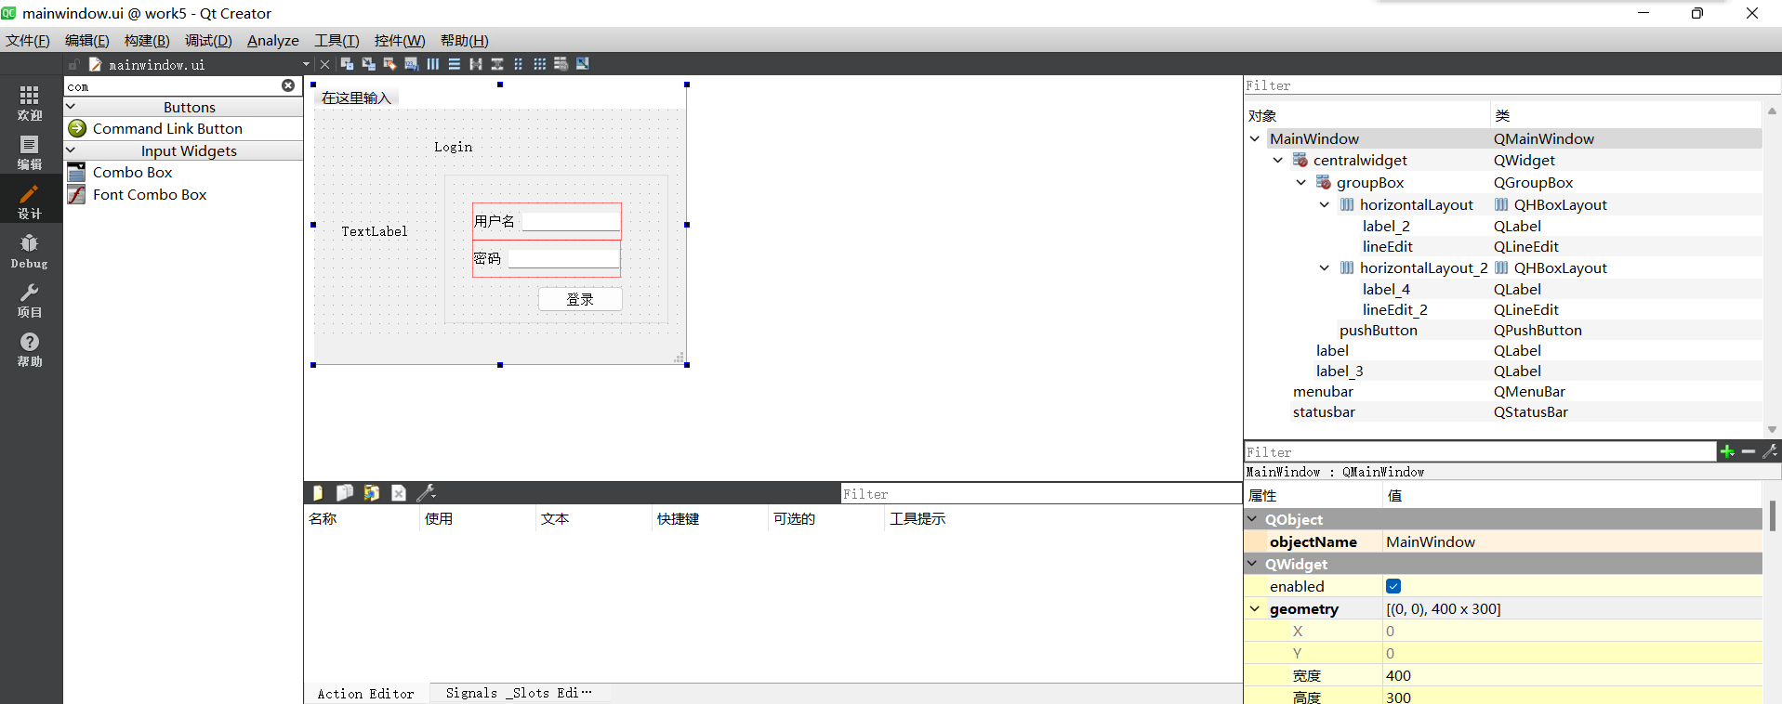

1. 在dialog中添加Label，PushBotton ;在dialog2中添加HboxLayout ,Label，PushBotton ,ComboBox ,LCDNumber ,LineEdit

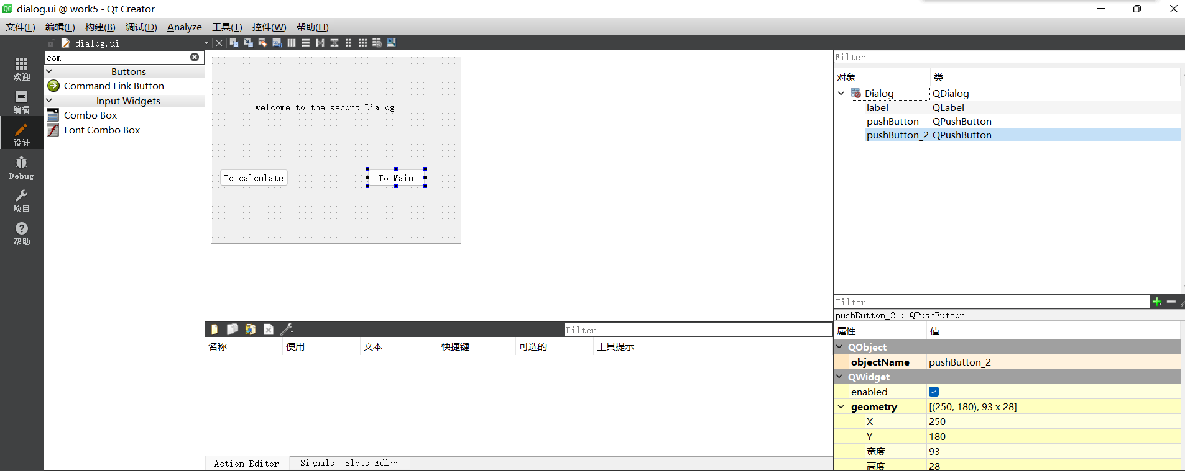

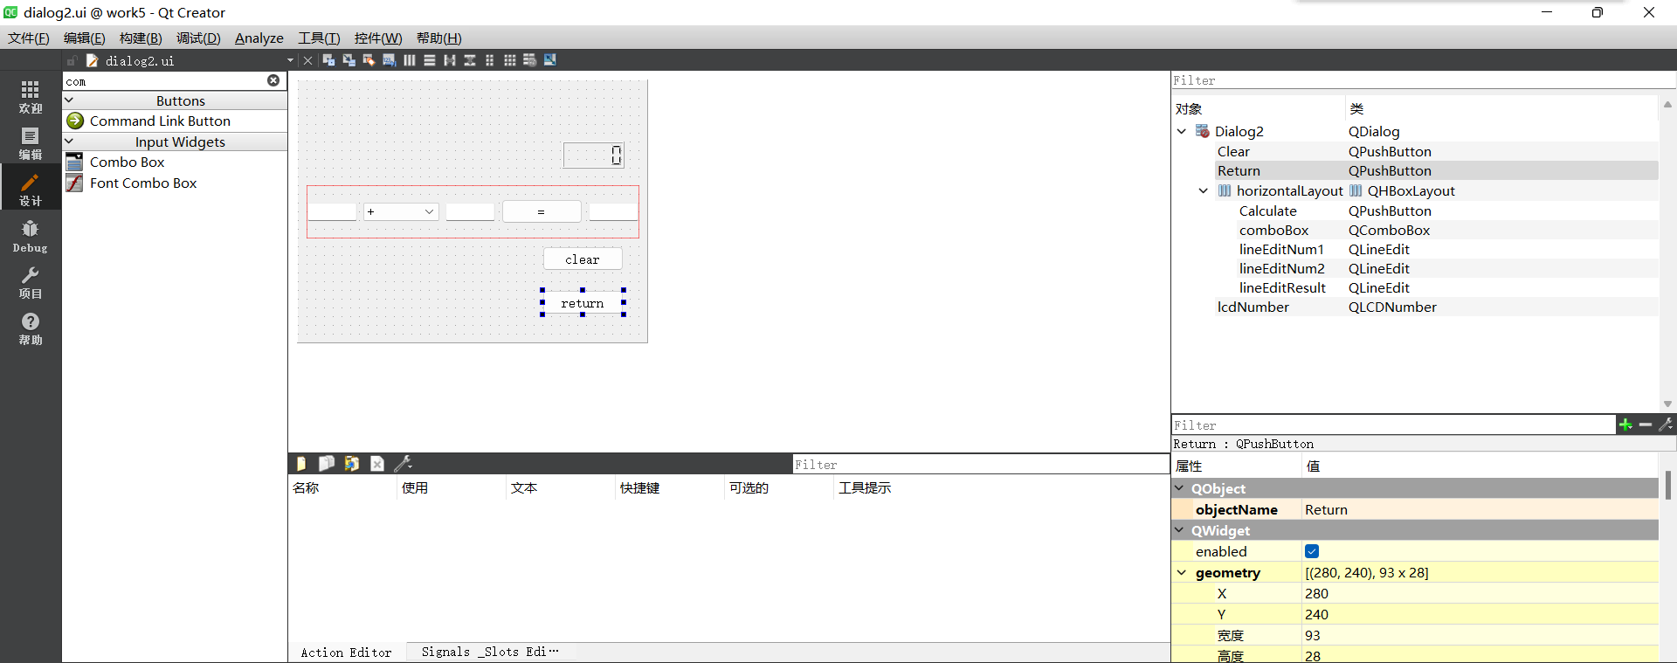

1. 添加转到槽代码

#include "mainwindow.h"

#include "ui_mainwindow.h"

#include<QMessageBox>

#include<QPixmap>

#include "dialog.h"

MainWindow::**MainWindow**(QWidget *parent)

: QMainWindow(parent)

, ui(new Ui::MainWindow)

{

ui->setupUi(this);

QPixmap pix(":/new/prefix1/img/3.jpg");

int w = ui->label_3->width();

int h = ui->label_3->height();

ui->label_3->setPixmap(pix.scaled(w,h,Qt::KeepAspectRatio));

}

MainWindow::~***MainWindow***()

{

delete ui;

}

void MainWindow::**on_pushButton_clicked**()

{

QString Username = ui->lineEdit->text();

QString password = ui->lineEdit_2->text();

if(Username== "Admin" && password== "123456"){

QMessageBox::information(this, "Login", "Username and password is correct");

Dialog secDeialog;

secDeialog.setModal(true);

secDeialog.*exec*();

//hide();

//Dialog = new Dialog(this);

//Dialog -> show();

}

else{

QMessageBox::warning(this,"Login", "Username and password is not correct");

}

}

}

}

1. 在dialog和dialog 2中添加代码

dialog:

#include "dialog.h"

#include "ui_dialog.h"

#include "dialog2.h"

#include "mainwindow.h"

Dialog::**Dialog**(QWidget *parent) :

QDialog(parent),

ui(new Ui::Dialog)

{

ui->setupUi(this);

}

Dialog::~***Dialog***()

{

delete ui;

}

void Dialog::**on_pushButton_clicked**()

{

Dialog2 *dialog2=new Dialog2; //给窗口2创建一个对象

this ->close(); //this是当前窗体（窗口1）的指针，关闭

dialog2 ->show(); //窗口2显示出来

}

void Dialog::**on_pushButton_2_clicked**()

{

MainWindow *m = new MainWindow;

this-> close();

m->show();

}

dialog 2:

#include "dialog2.h"

#include "ui_dialog2.h"

#include <QDebug>

#include <QMessageBox>

#include "dialog.h"

Dialog2::**Dialog2**(QWidget *parent) :

QDialog(parent),

ui(new Ui::Dialog2)

{

ui->setupUi(this);

ui->lcdNumber->setPalette(Qt::green);

ui->lcdNumber->setDigitCount(8);

ui->lineEditNum1->setValidator(new QRegExpValidator(QRegExp("[0-9\.]+$")));

ui->lineEditNum2->setValidator(new QRegExpValidator(QRegExp("[0-9\.]+$")));

}

Dialog2::~***Dialog2***()

{

delete ui;

}

void Dialog2::**on_Calculate_clicked**()

{

double num1 = ui->lineEditNum1->text().toDouble();

double num2 = ui->lineEditNum2->text().toDouble();

uint8_t index = ui->comboBox->currentIndex();

double result = 0.0;

switch (index) {

case 0:

result = num1 + num2;

break;

case 1:

result = num1 - num2;

break;

case 2:

result = num1 * num2;

break;

case 3:

if(num2 == 0)

{

qDebug("num2 is 0");

QMessageBox::about(this,"注意","除数不能为0");

return;

}

result = num1 /num2;

break;

default:

break;

}

ui->lineEditResult->setText(QString::number(result,'g',8));

ui->lcdNumber->display(result);

}

void Dialog2::**on_Clear_clicked**()

{

ui->lineEditNum1->clear();

ui->lineEditNum2->clear();

ui->lineEditResult->clear();

ui->lcdNumber->display(0);

}

void Dialog2::**on_Return_clicked**()

{

Dialog *dialog = new Dialog;

this ->close();

dialog->show();

}

1. 运行结果

